SOFTWARE
QUALITY ASSURANCE

Zaeem Nasir

Section A

241545771

DEPARTMENT OF COMPUTERSCIENCE FCCU

Java installation:

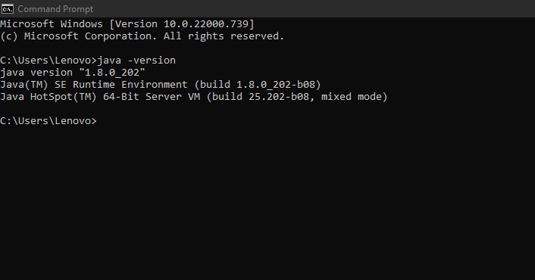

Jenkins installation:

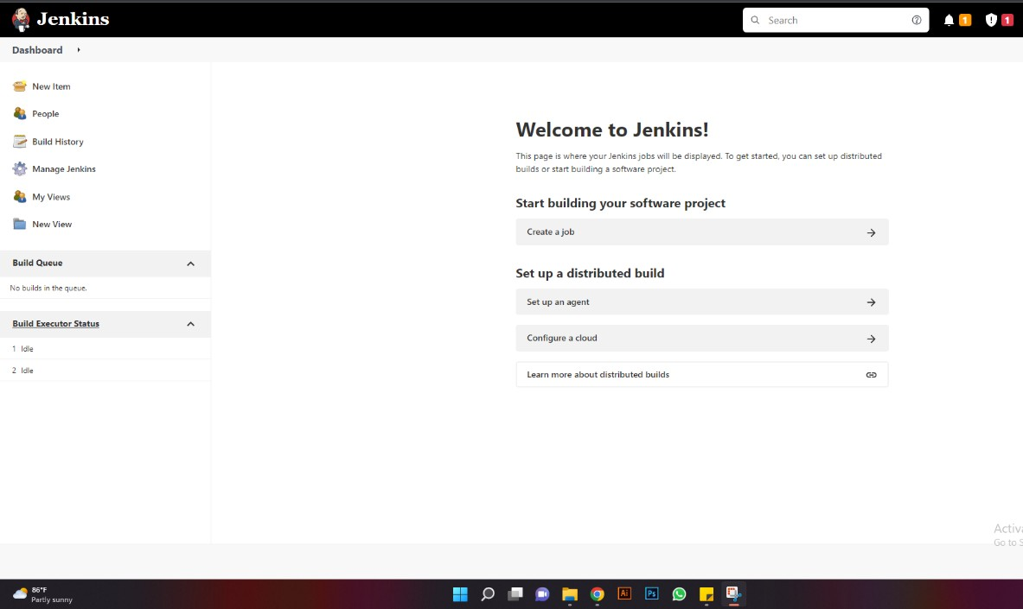

Creating pipeline:

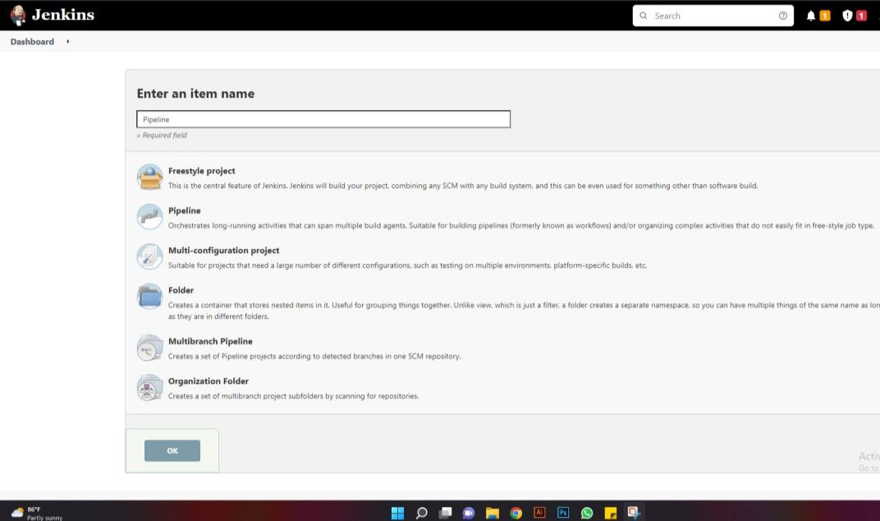

Creating pipeline stage:

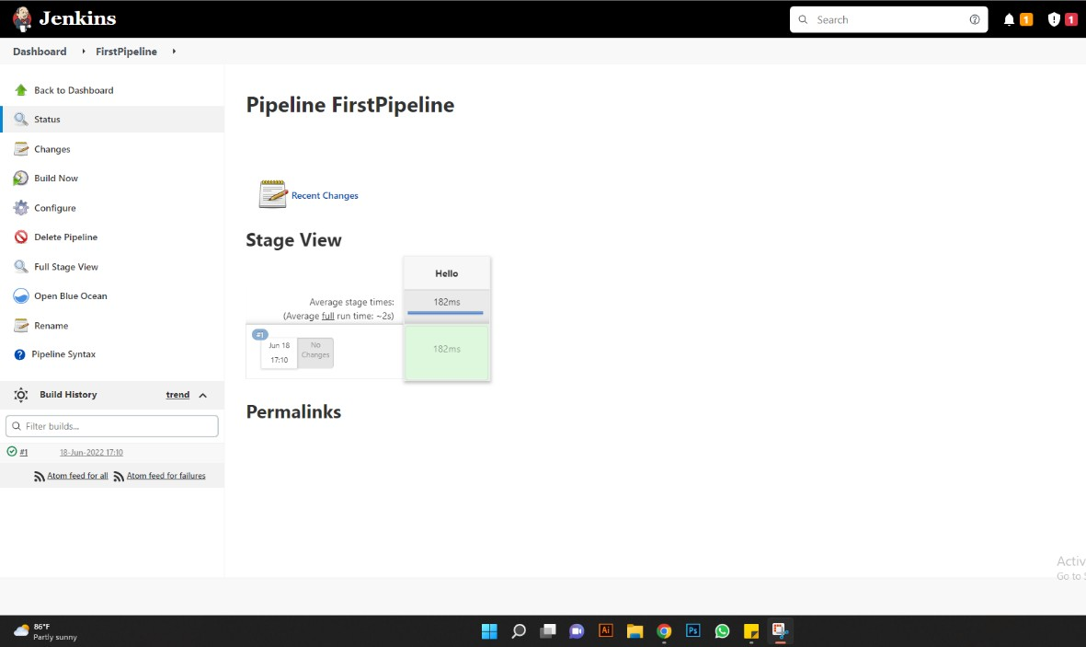
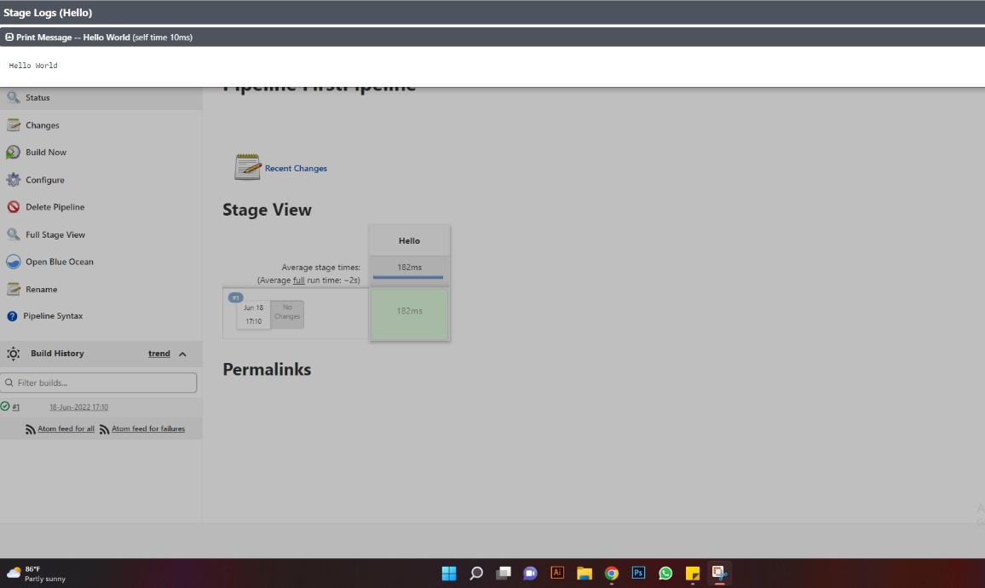

Creating CI/CD pipeline:

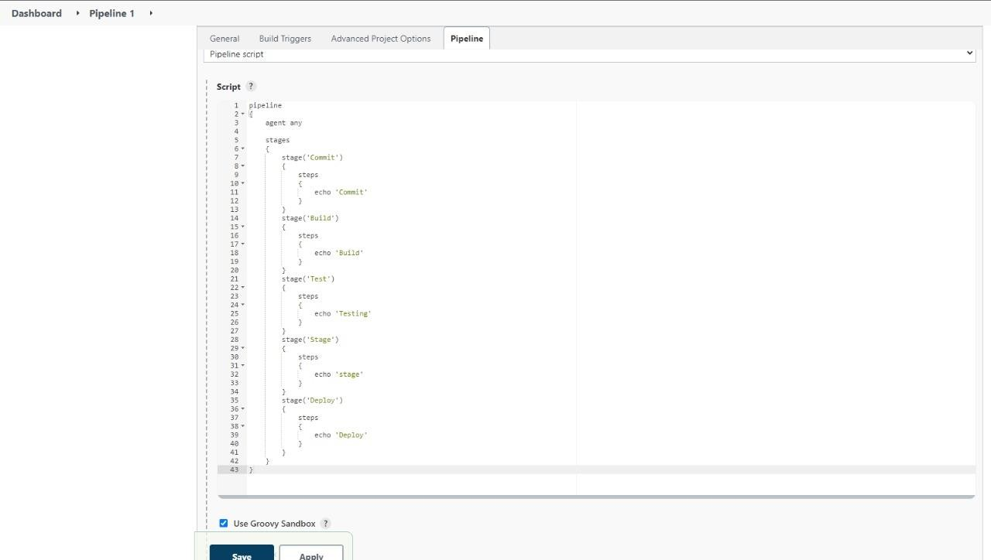

Running pipeline stages:

